UTS STRUKTUR DATA

Aldi Maulana Iqbal (20210801222)

1. Buatlah sebuah program Struktur Data Sorting untuk pengurutan data Dengan metode Bubble Sort Asending & Quick sort Desending.

**Fungsi *Bubble Sort Ascending*:**

// Bubble Sort Ascending Function

**void** bubbleSwapping(**int** &a, **int** &b)

{

**int** temp;

temp = a;

a = b;

b = temp;

}

**void** bubbleSortAsc(**int** *array, **int** size)

{

**for** (**int** i = 0; i < size; i++)

{

**int** swaps = 0;

**for** (**int** j = 0; j < size - i - 1; j++)

{

**if** (array[j] > array[j + 1])

{

bubbleSwapping(array[j], array[j + 1]);

swaps = 1;

}

}

**if** (!swaps)

{

**break**;

}

}

}

**Fungsi *Quick Sort Descending*:**

// Quick Sort Descending Function

**void** swap(**int** *array, **int** left, **int** right)

{

**int** temp = array[left];

array[left] = array[right];

array[right] = temp;

}

**int** partition(**int** *array, **int** left, **int** right)

{

**int** pivot = array[right];

**int** leftPointer = left - 1;

**int** rightPointer = right;

**for** (;;)

{

**while** (array[++leftPointer] > pivot)

{

}

**while** (rightPointer > 0 && array[--rightPointer] < pivot)

{

}

**if** (leftPointer >= rightPointer)

{

**break**;

}

**else**

{

swap(array, leftPointer, rightPointer);

}

}

swap(array, leftPointer, right);

**return** leftPointer;

}

**void** quicksort(**int** *array, **int** left, **int** right)

{

**if** (left < right)

{

**int** partitionPoint = partition(array, left, right);

quicksort(array, left, partitionPoint - 1);

quicksort(array, partitionPoint + 1, right);

}

}

**Main Code:**

#include <iostream>

#include <stdio.h>

#include <stdlib.h>

**using** **namespace** std;

**int** main()

{

**int** array[6] = {23, 10, 9, 12, 15, 20};

**int** arrayLeng = **sizeof**(array) / **sizeof**(**int**);

cout << " Array before sort: ";

**for** (**int** i = 0; i < arrayLeng; i++)

{

cout << "[" << array[i] << "]"

<< " ";

}

cout << endl;

bubbleSortAsc(array, arrayLeng);

cout << " Array after bubble sort asc: ";

**for** (**int** i = 0; i < arrayLeng; i++)

{

cout << "[" << array[i] << "]"

<< " ";

}

cout << endl;

quicksort(array, 0, arrayLeng - 1);

cout << " Array after quick sort desc: ";

**for** (**int** i = 0; i < arrayLeng; i++)

{

cout << "[" << array[i] << "]"

<< " ";

}

cout << endl;

}

**Hasil:**

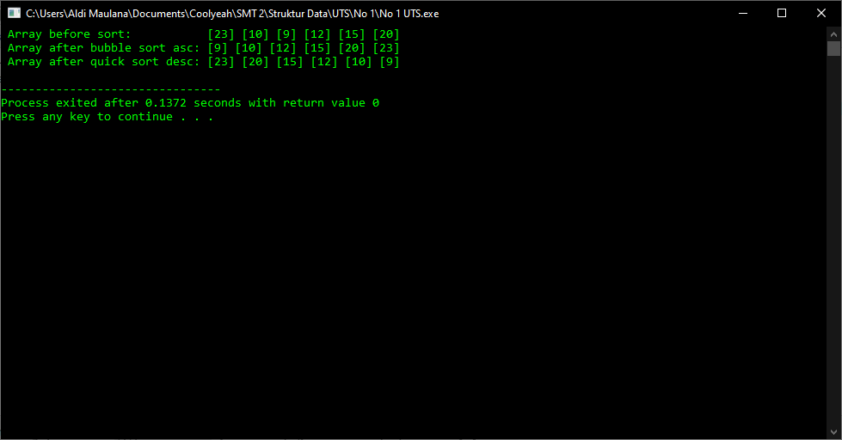

1. Buatlah sebuah program Struktur Data Searching (mencari) data yang huruf nya dimulai dengan Yu* pada Data yang tersimpan dalam Array 1 dimensi berikut ini sampai di temukan semua data yang huruf awalnya Yu*.

**Source Code:**

#include <iostream>

#include <string>

**using** **namespace** std;

**void** displayIndex(**int** size)

{

**for** (**int** i = 0; i < size; i++)

{

cout << i << "\t ";

}

}

**void** displayData(string *array, **int** size)

{

**for** (**int** i = 0; i < size; i++)

{

cout << array[i] << "\t";

}

}

**int** main()

{

string data[9] = {"Anton", "Yusuf", "Azzah", "Jojon", "Yahya", "Naura", "Ester", "Yunus", "Aisyah"};

string search;

**int** dataLeng = **sizeof**(data) / **sizeof**(string);

cout << "Index : ";

displayIndex(dataLeng);

cout << endl;

cout << "Data : ";

displayData(data, dataLeng);

cout << "\n\n";

cout << "Masukkan kata kunci pencarian : ";

cin >> search;

cout << endl;

**bool** found = **false**;

**for** (**int** i = 0; i < dataLeng; i++)

{

**if** (!data[i].find(search))

{

cout << data[i] << " Index Ke-" << i << " | ";

found = **true**;

}

}

cout << endl;

**if** (!found)

{

cout << "Data Not Found! Try Again!";

}

}

**Result:**

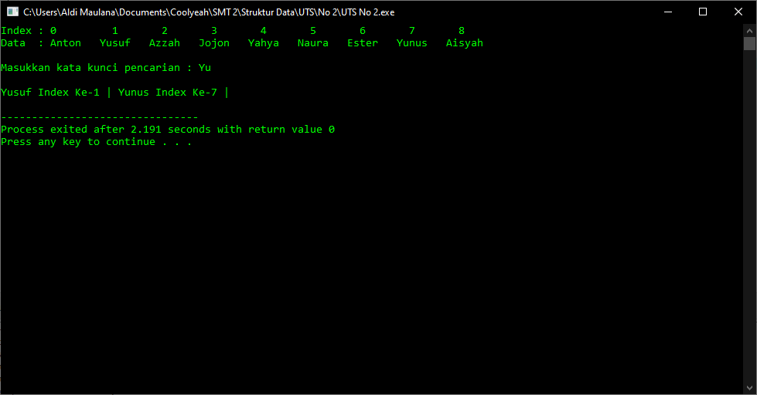

1. Buat script StrukturData + Algoritma dengan salah satu tools (C++, Java, JavaScript, PHP, Python, dan lainya) untuk mencetak Sederetan Data Kuadrat bilangan ganjil seperti dibawah ini, Dimana ada Nilai total Dan nilai rata rata nya.

**Source Code:**

#include <iostream>

#include <cmath>

**using** **namespace** std;

**int** main()

{

cout << "Deret Kuadrat Bilangan Ganjil" << endl;

**int** num = 1;

**int** sum = 0;

**while** (num <= 19)

{

cout << "[" << num * num << "] ";

sum += num * num;

num += 2;

}

cout << "\n\n";

cout << "Total nilai deret = " << sum << endl;

cout << "Rata nilai deret = " << (**float**)sum / 10;

}

**Result :**

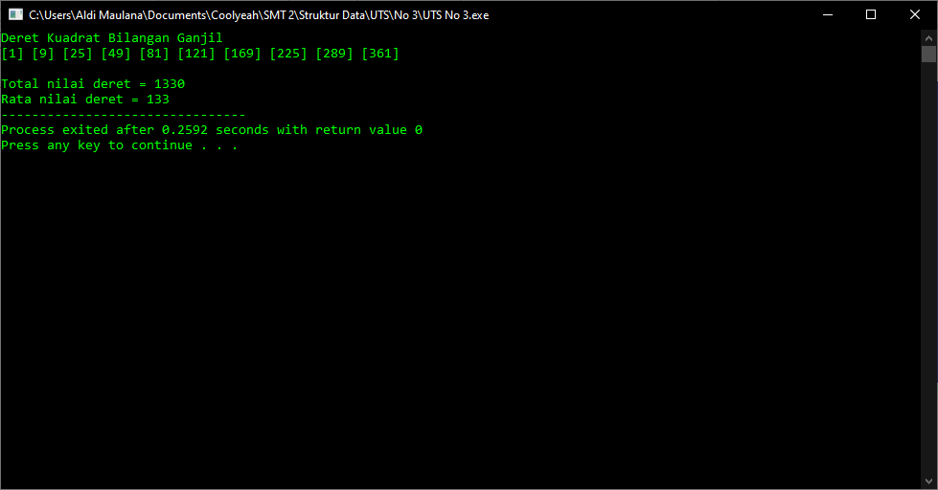

1. Bila data Mahasiswa : Nim, Nama, dan IPK yang akan ditampilkan 5 data Mahasiswa, deklarasikanlah struktur Mahasiswa tersebut dgn struktur pointer to array, Buatlah fungsi/prosedure input data dan fungsi atau prosedure tampilan datanya.

**Source Code:**

#include <iostream>

#include <string>

**using** **namespace** std;

**struct** Mahasiswa

{

string nama;

string nim;

string ipk;

string keterangan;

};

**int** main()

{

**char** tab = '\t';

**int** jmlhMhs = 5;

**int** firstCat = 0;

**int** secondCat = 0;

**int** thirdCat = 0;

**int** uncategorizedCat = 0;

Mahasiswa mhs[jmlhMhs];

**for** (**int** i = 0; i < jmlhMhs; i++)

{

cout << "Data-" << i + 1 << " : "

<< "Entry Data" << endl;

cout << " Nama : ";

getline(cin, mhs[i].nama);

cout << " NIM : ";

getline(cin, mhs[i].nim);

cout << " IPK : ";

getline(cin, mhs[i].ipk);

**int** ipk = stoi(mhs[i].ipk);

**if** (ipk >= 88)

{

mhs[i].keterangan = "Sangat Memuaskan";

firstCat++;

}

**else** **if** (ipk >= 77 && ipk <= 88)

{

mhs[i].keterangan = "Memuaskan";

secondCat++;

}

**else** **if** (ipk >= 60 && ipk <= 76)

{

mhs[i].keterangan = "Cukup";

thirdCat++;

}

**else**

{

mhs[i].keterangan = "Uncategorized";

uncategorizedCat++;

}

}

cout << " DAFTAR NAMA MHS STRUKTUR DATA " << endl;

cout << "--------------------------------------------------------" << endl;

cout << "No.\t\tNama\t\tNIM\t\tIPK\t\tKET." << endl;

**for** (**int** j = 0; j < jmlhMhs; j++)

{

cout << j + 1 << tab << tab << mhs[j].nama << tab << tab << mhs[j].nim << tab << tab << mhs[j].ipk << tab << tab << mhs[j].keterangan << endl;

}

cout << endl;

cout << "Jumlah predikat sangat memuaskan = " << firstCat << "\tOrang." << endl;

cout << "Jumlah predikat memuaskan = " << secondCat << "\tOrang." << endl;

cout << "Jumlah predikat cukup = " << thirdCat << "\tOrang." << endl;

cout << "Jumlah predikat uncategorized = " << uncategorizedCat << "\tOrang." << endl;

}

**Result:**

